# SICILY TOUR

**Highlights of Sicily Tour**

**offered to Fromm Institute Lifelong Learning students,**

**21-31 May, 2024**

Sicily is best toured on a circular route, with Catania as the place to arrive and Siracusa the place to start. History in Sicily began in the east, where the Greeks arrived and, especially in Syracuse, where the first and greatest golden age of Sicily flowered. Then we follow a clockwise circuit of the greatest sights of the island, returning to the east for a restful epilogue at Taormina, before you leave for home from Catania. This is how you might understand Sicily’s story as you enjoy her infinite variety, in a relaxed and comprehensible chronological order.

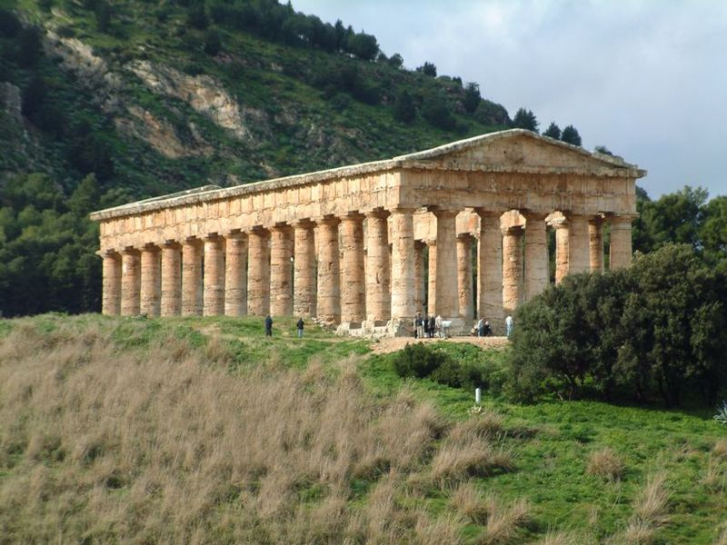**Day 1**, Tues, 21 May -- Arrive in Catania. We meet you at the airport and take you to a charming hotel in the ancient city center of Siracusa, Ortigia. When everyone has arrived, we’ll have a welcome meeting. As you may be jet-lagged, the first day will be reserved for settling in and getting oriented. That includes an afternoon walk around the incredible island-peninsula of Ortigia, its palaces, narrow lanes, unique cathedral built around a Greek temple, Jewish Quarter, Arethusa Spring,. Welcome dinner at a favorite Siracusa restaurant (incl.[1]) and overnight at Siracusa. (*Hotel Livingston* or *equivalent*)

**Day 2**, Wed, 22 May – 0830, we begin our grand tour of Siracusa (UNESCO world heritage), for two centuries the greatest of ancient Greek cities, beginning with the world’s only surviving ancient Greek fort and its lovely overlook of the coast, or the 13C castle that guards the harbour. We continue on to one of the world’s finest Greek Theatres, the Ear of Dionysius, and the Roman Amphitheatre. Afternoon free, on your own. Optional opportunity in the late afternoon for our highly praised (UNESCO) Sicilian marionette (*pupi*) theatre[2] and, in May & June, you have an optional opportunity for a performance at the Greek Theatre.[3] Dinner on your own (we’ll have suggestions) and overnight at Siracusa. (*Hotel Livingston or equivalent*)

**Day 3**, Thu, 23 May – Day on your own in Ortigia and uptown Siracusa. Options include the world-class Paolo Orsi Archaeological Museum, the nearby Christian catacombs (world’s 2nd largest), and a Caravaggio, all uptown. In Ortigia are other museums (incl. medieval art, papyrus, numismatic, etc.), a 13C Frederick II castle (Maniace), two medieval-Norman churches, a unique Byzantine-period Jewish *miqwe*, a sightseeing boat trip, an Archimedes exhibit comparing his engineering with his disciple Leonardo da Vinci), an hypogeum under Piazza Duomo, regular exhibits, musical and other artistic events, including in May and June another different play in repertory at the Greek theatre. Of course, you might also sleep late and spend time swimming in the sea (a few steps from the hotel), sitting in cafés watching street life, and being a part of the *passeggiata*. Overnight in Siracusa. (*Hotel Livingston or equivalent*)

**Day 4**, Fri, 24 May – 0830, we depart Siracusa to visit Noto, a UNESCO world heritage site of honey-gold baroque, before continuing through the ancient and storied Hyblean Highlands to lunch at a dairy farm where Carmella treats us to produce of the farm (incl.) and a farm tour by her son. Afternoon visit to a panoramic overview of the charming town of Modica followed by a short walking visit to old Ragusa (Ragusa Ibla). Onto your hotel in Piazza Armerina. Light dinner (incl.) and overnight in Piazza Armerina (*Torre di Renda or equivalent*).

**Day 5**, Sat, 25 May **–** 0830,morning visit of the Roman Villa del Casale at Piazza Armerina (UNESCO) with the greatest mosaic floors of the ancient world. Then we travel further out across rolling countryside to the remote vineyards of *Feudo Principi di Butera* for a wine tasting, elegant light lunch, and tour of the cellars (incl.). Finally we take an afternoon drive on country roads to Agrigento (UNESCO), talking of the WWII allied landings & battles, to visit Greek temples equal to those in Greece itself. Dinner on your own and overnight in Agrigento in a hotel overlooking the temples. (*Hotel Colleverde* or *equivalent*).

*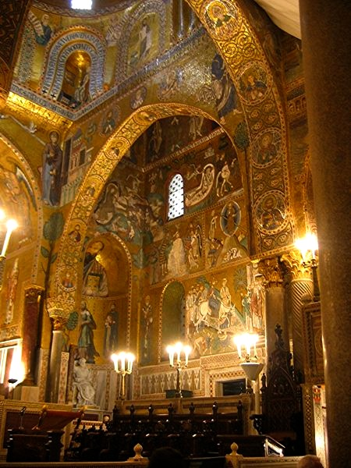***Day 6**, Sun, 26 May – 0830, we travel west along the less visited south coast to the ruins of the Greek city of Selinunte, the third great city of the Greek west, on its evocative windswept coastal site. There will be an option of salad buffet lunch at a beach place or picnic in the quiet and remote Greek quarry site of Cave di Cusa. Then, we proceed through Marsala, talking of Garibaldi, Carthage, and Marsala wine, to the salt flats and romantic windmills of far western Sicily, including the Carthaginian site of Mozia, to visit perhaps the greatest existing Greek sculpture. Dinner (incl.) and overnight in charming converted convent in old town Marsala (*Hotel Carmine or equivalent*).

**Day 7**, Mon, 27 May **–** 0830, we continue to Erice and tour the ancient mountaintop town founded by Aphrodite, ruled by Hercules, where a cult of sex once flourished. We sample the pastries at Maria Grammatico’s shop, made famous by her (and Mary Simeti’s) book *Bitter Almonds.* We turn north to visit the incomparably beautiful temple at Segesta, a town Virgil tells us was founded by Aeneas. Dinner at one of the best restaurants for traditional Sicilian cuisine (*Altri Tempi*, incl.) and overnight in Palermo. (*Hotel Piazza Borsa or equivalent*)

**Day 8**, Tues, 28 May – 0830, a morning walking tour of the incredible sites of Arabo-Norman Palermo (UNESCO), including matchless gems like the Palatine Chapel (the artistic pinnacle of the High Middle Ages) and La Martorana. We lunch (not incl) at Focacceria San Francesco, famous for its Slow Food and anti-Mafia virtues. In the afternoon, you are free to pursue your own interests in Palermo (we'll have recommendations). Dinner on your own and overnight in Palermo. (*Hotel Piazza Borsa or equivalent*)

**Day 9**, Wed, 29 May **–** 0830, Following a visit to Baroque frenzy of Casa Professa and the culinary frenzy of the Ballarò Market, we go up to visit the Norman cathedral of Monreale, and the greatest mosaic cycle in existence. Then we drive along the coast to Cefalù, for a few hours in this charming medieval seacoast town, where you will be on you own to visit another Norman cathedral, shop, lunch (not incl.), climb the great rock, or swim at one of Sicily’s most celebrated beaches. Then we continue into the Madonie mountains to our hotel, *Relais Sant’Anastasia*, in an ancient abbey where they have been making wines for a thousand years. Organic wine tasting with dinner (incl.). Overnight at *Relais Sant’Anastasia*. (Alternatively, we could remain in Cefalù for dinner at our favorite seafood restaurant overlooking the sea and overnight in old town Cefalù (*La Plumeria Hotel or equivalent*)), or drive further along the coast to stay at another mountain resort (*Antica Filanda*).

**Day 10**, Thu, 30 May – 0830**,** we start our drive along the scenic north coast, with views and stories of the Aeolian Islands. Check into your hotel in Taormina, lunch and walking tour of the antique theatre and town. Farewell lunch (incl.), free afternoon, and overnight. (*Villa Fiorita or equivalent*).

**Day 11**, Fri, 31 May – We will take you to Catania airport for your flight home, unless you have taken the option of remaining longer in Taormina or have other plans (let us know in advance).

**HIGHLIGHTS TOUR COST:**

**€ 3995**[4] per person in double occupancy

**Tour Cost Includes:**

* Bed and Breakfast accommodation on twin sharing basis. All accommodation will be of a three-star or higher standard, specially selected by us for quality, ambience, and the friendliness of the staff. All hotels have websites for your inspection.
* Ten breakfasts and nine other meals as indicated in the itinerary as “incl.”.
* A cooking class and two winery tastings of Sicily wines.
* Entrance fees for all activities mentioned in this itinerary, except those designated as “optional”, and only these.
* An English-speaking Sicily Tour host / guide to be with you during all activities mentioned in this itinerary, except for time periods noted as “free”.
* All presentations will be in English or an interpreter will be present.
* Air-conditioned chauffeur-driven vehicle throughout the tour.
* All applicable government taxes, service charges, and paperwork.
* Ground transport from and to Catania airport, at the beginning and end of the tour, within announced arrival & departure windows.[5]

**Tour Cost Does not Include:**

* Airfare to and from Catania Fontanarossa Airport.
* Passport applications and fees. Passports are required for entrance into Italy.
* Travel or health insurance. We recommend both.
* Single supplement charges equaling 30% of the full tour cost.[6]
* any activities described as “optional”.
* Meals or beverages not specified as “incl.”.
* Expenses of a personal nature.

**optional additions to the basic Highlights Tour**

Just let us know if you are interested in any of these when first you sign on with us.

1. ***Taormina extension* option** (unlimited days after our tour)

After we have said goodbye and Sicily Tour’s responsibility for you has concluded (except for transfer to the airport), some people like to linger a few days in Taormina. It is, after all, Sicily’s best-known place for high-end shopping, relaxing amid dramatic scenery, elegant dining, concerts, street performances, and local attractions like Daphne Phelps’ house. Also for longer excursion options around eastern Sicily, including *Godfather* film sites, Catania, Mt. Etna, Messina, and full-day trips to the Aeolian Islands or the Riace Bronzes at Reggio Calabria.

If this appeals to you, let us know. With advance notice, we can arrange for you to stay over at the hotel for as many days as you like, and then still take you to Catania airport for your flight.

Cost: € 390 per couple per day (includes only the hotel & the difference in cost of an airport taxi just for you (higher than the discounted rate we get for the usual group transfer to Catania airport). .

2. ***Mount Etna, cable car and 4WD*** (one day, before or after our tour)

*Etna is the world’s most storied mountain, one of its most resonant and mythic places. It is also Europe’s most active volcano and Sicily’s beloved grandfather (or grandmother depending on his/her mood).*

easy visit

We depart Taormina, ascending two-thirds up the slopes of Etna to the Rifugio Sapienza area.

At this point, there will be a cable-car and 4WD service ( *incl*) up another 4000 feet to see up close the smoking vents in the company of an official Etna alpine guide.

Later, we proceed down the east slopes of Etna. Wine-tasting and outdoor light lunch (*incl*) at a small winery with views over the Mediterranean.

We return you to your hotel in Taormina.

hiking. Alternatively, if you prefer hiking and to avoid the crowds, there are hiking options on Etna: half day, full day, or multiple days.

Cost: Please ask for a quote for this option, which will depend on several variables.

3. **Your own ideas**. Let us know what else you might have in mind to do and we might be able to arrange it.

Douglas Kenning / Lucia Davies / Stephen Davies

*Sicily Tour*   
+39 334 882 8397 (Lucia)

[www.Sicily-Tour.com](http://www.Sicily-Tour.com)

[sicilytour31@gmail.com](mailto:Sicilytour31@gmail.com)

1. “incl.” = “included”, means you’ve already paid for it, which implies we do it as a group. Of course, you still may opt out of the occasion, as you can any of our activities, so long as you are present for our next minibus departure. Refunds are possible for “incl.” events you have not attended only if they were not prepaid by us.
2. theatre performance dates & times variable; check with us. Marionette museum nearby is usually open daily.
3. not included & you must schedule this with us in advance of the tour. See <https://www.indafondazione.org/en/> for the program.
4. This price is in Euros. Price in US $ will of course depend on exchange rate your bank will use when you make payment. € 900 deposit secures a place.
5. Arrival Window: our pickup will collect you between 11~1400 on Day 1. Departure Window: we will take you to the airport on Day 11, if your flight is before noon, promising to have you at the airport no later than 75 minutes before your flight). See our “Terms and Conditions” page for more details.
6. Single Supplement fee is unfair, we agree. But there is nothing to be done, since hotels charge single travelers on average 80~90% of the room price they charge a couple. If you are a single traveler, best to bring a partner or ask us if there is someone on the tour wanting a roommate, or other ways we can reduce your cost (there are ways).