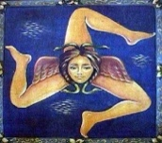
“Introduction to Tunisia” tour itinerary
led by Douglas Kenning

group leader: Douglas, phone +216 95 434 641
Tunisia tour guide: Ridha, phone: +216 98 260 861

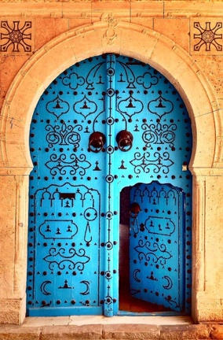
Nov 4 (Fri): ARRIVAL. Our taxi (driver with “Sicily Tour” sign, incl.) will meet you at Tunis Carthage airport & take you to our hotel in romantic Sidi Bou Said. We’ll have greetings & orientation in the hotel (18:00 6:00pm), then proceed to our welcome Dinner at Dar Zarrouk (incl.). Overnight in Sidi Bou Said (Hotel Dar Said).

Nov 5 (Sat): CLASSICAL, ARAB, & FRENCH TUNIS. 0900, morning orientation on Tunis, including French colonial atmosphere of the Ville Nouvelle, taking in the matchless Bardo Museum of ancient mosaics. Lunch at 1330 at El Ali Restaurant in the Medina (incl.). Afternoon walkabout through the souk of the Tunis Medina (UNESCO), before returning to Sidi Bou Said. Dinner on your own, & overnight in Sidi Bou Said (Hotel Dar Said).

Nov 6 (Sun): CARTHAGE. 0830, full day visit to ancient Carthage (UNESCO), including the Byrsa, Punic port, Tophet, Roman villas & baths, & the North African American War Cemetery. Dinner on your own, & overnight in Sidi Bou Said (Hotel Dar Said).

Nov 7 (Mon): TUNIS –TESTOUR– DOUGGA—KAIROUAN. 0830 departure for Testour, a town of Andalusian heritage, where everyone will buy their own lunch ingredients in the street market (choosing among fresh cheese, bread, olives, olive oil, harissa, tuna, tapenades, Tunisian pastries, & fresh fruit in season), to carry to our picnic lunch at lovely remote Dougga. Here we’ll visit the most complete ancient Roman city in existence (UNESCO). We continue to Kairouan, for dinner at the Kasbah restaurant (incl.) & overnight in Kairouan (Hotel Kasbah).

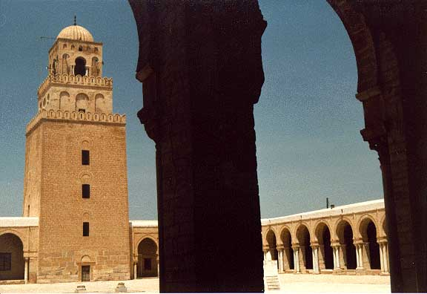
Nov 8 (Tue): KAIROUAN. 0830, we’ll walk the old city (UNESCO) & visit historic monuments including the most important mosque of North Africa (Mosque Okba), the lovely Mosque Sidi Sahib (Mosque of the Barber); & a look at Kairouan’s famous carpets. We’ll find lunch (not incl.), then you’ll have the afternoon-evening in Kairouan for wandering the medina & relaxing. Dinner on your own (we’ll have recommendations) & overnight in Kairouan (Hotel Kasbah).

Nov 9 (Wed): KAIROUAN—SBEITLA—TOZEUR. 0830, we’ll drive from Kairouan to Sbeitla to walk this extensive ancient Roman & paleo-Christian city. Lunch will be at a restaurant nearby (not incl). Then we drive south, passing ancient Gafsa, to Tozeur, gateway to the Sahara. Dinner on your own (we’ll have suggestions) & overnight in Tozeur (Dar Saida Beya Guesthouse).

Nov 10 (Thu): TOZEUR. 0830, morning visit to the historic quarter of Tozeur & Eden Palm Oasis (Palmerie) & folk museum (not incl). Lunch on your own. Afternoon will offer an option for a jeep ride (not incl.) out to the dramatic oases of Chebica & Tamerza, & Mides village, or an afternoon of free time to visit Tozeur, souk, & oasis, on your own. Here happens the International Oasis Festival every December. Dinner on your own & overnight in Tozeur (Dar Saida Beya Guesthouse).

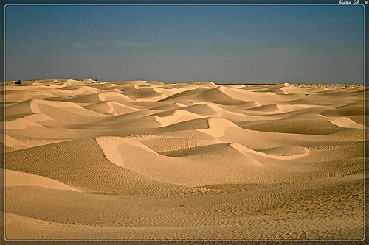
Nov 11 (Fri) TOZEUR—SALT LAKE—ZAAFRANE—DOUZ. 0830, we continue south across the vast, mirage-producing salt flat (the Chott) through Kebili, where there is a November Date Harvest Festival, to Zaafrane, beginning of dune country, & an optional camel ride (not incl.). We continue to the oasis town of Douz for lunch (not incl.) & some brief time in the souk. Dinner (incl. à la carte) & overnight in Douz (Hotel El Mouradi).

Nov 12 (Sat): DOUZ—CHENINI—KSAR OULED SOLTANE—MATMATA. 0700, we go through desert landscapes south into Berber ksar country toward Tataouine area. Here we’ll visit a few of these remarkable fortified cliff-hanging storehouses (ksar) including the dramatic cliff village of Chenini, with its Mosque of the Seven Sleepers; & the fascinating Ksar Ouled Soltane. This is where our trip turns north, along the scenic Dahar heights to Matmata. Dinner (incl., buffet) & overnight at Matmata (Dar Matmata Hotel).

Nov 13 (Sun): MATMATA—MARETH—SFAX. 0830, we visit a Berber family’s troglodyte home (we’re in Star Wars country), then continue north, stopping briefly at Mareth to oversee the WWII campaigns in Tunisia. We drive to our Sfax hotel with the option of a walking tour of the untouristed Sfax medina. Dinner (incl.) of Sfaxian recipes with chef Salma, a most excellent cook & wonderful hostess, in her elegant home (Dar Salma). Overnight in Sfax (Hotel Les Oliviers).

Nov 14 (Mon): SFAX—EL DJEM –– SOUSSE—HAMMAMET. 0800, we drive north to visit the unexpected, stunning El Djem amphitheatre (UNESCO) & the nearby Archaeological Museums & Roman villas with huge & lively mosaics. We continue to Sousse (UNESCO) for free time to have lunch (on your own) & visit the 9C Ribat (from whose tower you can look out to sea & into the mosque & wander the Medina. Dinner (on your own) & overnight in Hammamet (Radisson Blu).

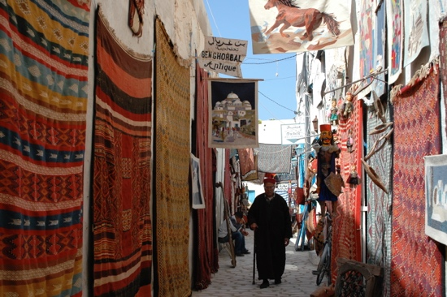
Nov 15 (Tue) HAMMAMET—KERKOUANE—--EL HAOUARIA—SIDI BOU SAID. 0830, we drive sea road of the lovely Cap Bon peninsula to the Carthaginian site of Kerkouane (UNESCO), where a Carthaginian town was discovered virtually undisturbed. Then we stop at El Haouaria to have lunch (not incl.) at a Carthaginian quarry site on a lovely seaside, then continue on to Tunis, & our hotel at the edge of the UNESCO-honored Tunis souk. Dinner (on your own) & overnight in Tunis (Hotel Royal Victoria).

Nov 16 (Wed) : TUNIS. Free day in Tunis, when you could perhaps return to Sidi Bou Said, or Carthage, or simply wander or shop in the adjacent Tunis souk (on your own). Farewell dinner at Dar el-Jeld (meet 19:30, 7:30pm, incl.) in the souk & overnight in Tunis (Hotel Royal Victoria).

Nov 17 (Thu): DEPARTURE FROM TUNISIA. Taxi transfer from hotel to Tunis Carthage Airport (incl.) for outgoing flight.

N.B.: Tunisia will welcome you with great friendliness, but do not expect everything to work with the certainty to which you may be accustomed. Meals overwhelm you with generosity, but selections may be of a limited range. In our accommodations, we promise you character, but not always luxury: on occasion things like internet or room heat can be spotty. We will attend to any problems & usually can solve them. All hotels have websites for your inspection. The itinerary also cannot be guaranteed, though I will try to give you the latest version & if something is cancelled we will try to substitute it with another activity of equal interest.

price (either tour) =
double/twin room -- $ 3290 ($ US), € 3130 (EUR), double occupancy.

single supplement = $800 ($ US), € 760 (EUR)
deposit to hold your place = $400 or €360 / person

group size (either tour): 8-16.
tour cost includes:

- Two tour leaders: Douglas Kenning & our Tunisia expert guide.
- Bed & Breakfast accommodation on twin sharing basis. All accommodation will be of a three-star or higher standard, selected by us for quality, ambience, & the friendliness of the staff. All hotels can e researched online.
- 13 breakfasts & 6 other meals as indicated in the itinerary as “incl.”.
- Entrance fees for all activities mentioned in this itinerary & only these.
- $500 tax-deductible donation to Humanities West of San Francisco
- An English-speaking host / guide to be with you during all activities mentioned in this itinerary.
- Presentations at all times in English, a few times through an interpreter.
- Air-conditioned chauffeur-driven vehicle throughout the tour.
- All applicable government taxes, service charges, & paperwork.
- Ground transport from & to Tunis airport, at the beginning & end of the tour, within announced arrival & departure windows.

Tour cost does not include:

- Airfare to & from Tunis Carthage airport.
- Passport fees. Passports with at least 6 months of validity are required for entrance into Tunisia.
- Travel or health insurance. We recommend both.
- Single supplement charges approximating 25% of the full tour cost.
- Any activities described as “optional”.
- Meals not specified as “incl.”.
- Drinks at any meal, including included (“incl.”) meals.
- Tips & porterage.
- city taxes (3 TND / person / day)
- Expenses of a personal nature.

CANCELLATION POLICY

If you must cancel your reservation after making a deposit, the following fees apply. Again, we strongly advise buying travel (cancellation) insurance.

days before Tour | Cancellation fee/Refund per person
45+ | deposit is forfeited, any other payments refunded
31-45 days | 25% of total invoice is forfeit (refund 75%)
15-30 days | 50% of total invoice is forfeit (refund 50%)
0-14 days | 100% of total invoice is forfeited (refund 0%)

N.B.: the Bardo is closed as of writing this and we have no timetable for its reopening. If not open when we are touring, we will take more time for the Tunis souk / Medina, perhaps leaving more afternoon time free for wandering on your own.
This excursion requires ability to walk up and downhill on rocky & uneven ground.
we will be on the road for several hours before finding a toilet, so you might reconsider coffee or tea this morning.
An annoying thing, but cities & governments across Europe and elsewhere have begun nickel-and-diming travelers by imposing a head tax on hotels. They don’t want to be blamed for it, so pass it on. We’d rather not be blamed for it either so, so far, like them have not folded it into the price.

