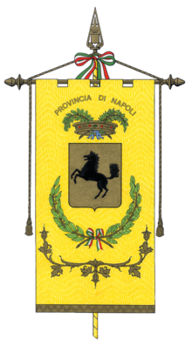
SICILY TOUR

The other half of Italy:

Naples and Mezzogiorno Itinerary
with Douglas Kenning
itinerary draft version: 3-Nov-23
Our tour takes us around the Mezzogiorno, which you can guess means “the middle of the day”, a.k.a. “noon”, and is the nickname for the half of Italy from Naples to the south, alluding to the powerful midday sun in this sun-drenched region (be reassured, we are traveling in mild October). Here is a region with utterly different history from northern Italy for three-quarters of the history of the Italian peninsula: ancient Greeks, Normans, Arabs, Aragonese, Spanish, all of whom ruled and shaped the culture of the Mezzogiorno, none of whom were in north Italy. Here you meet a half of Italy that seems a millennium older.

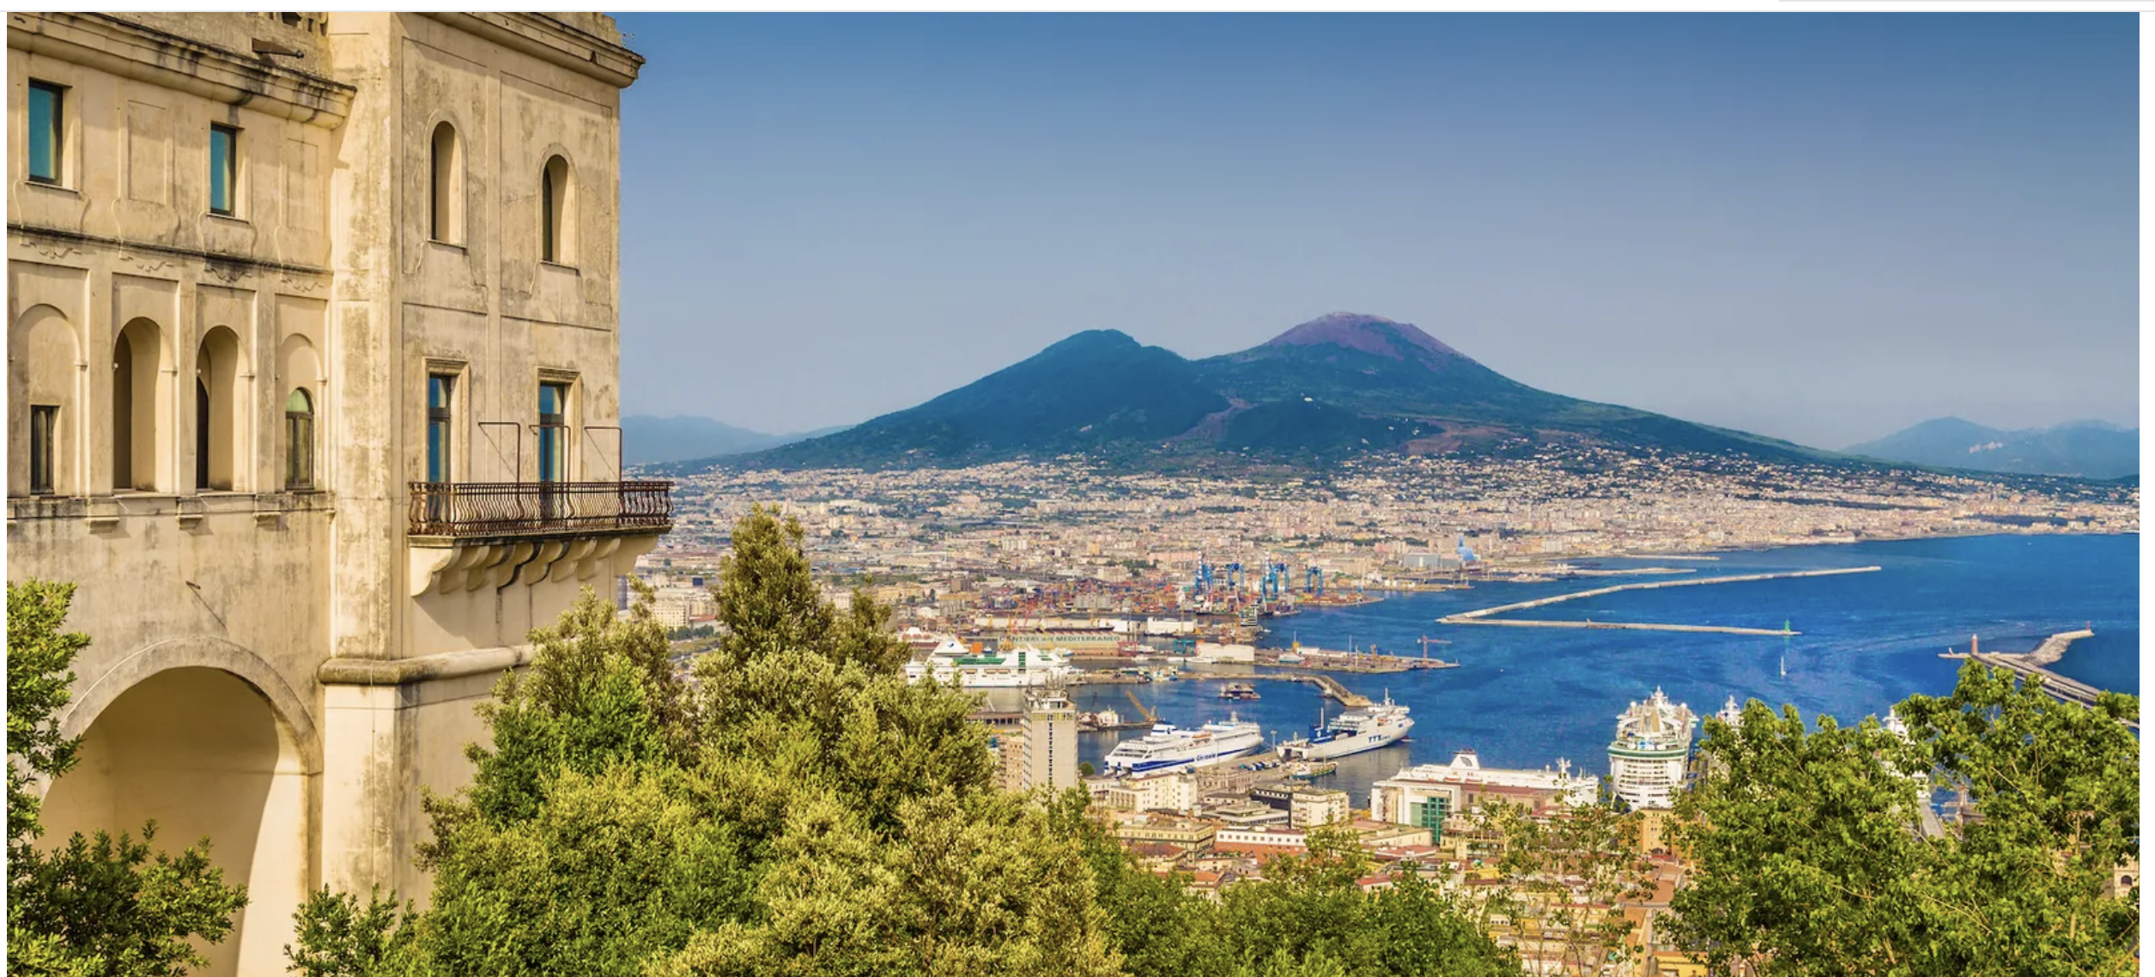
week 1: Naples and her glorious Bay

We begin in the Bay of Naples, where we find the oldest ancient Greek colony west of Greece itself, the seat of a Sibyl, islands of the Sirens, Vesuvius and the Roman cities she destroyed, the stunning Baroque palace of Caserta, the fabled Amalfi Coast and Isle of Capri, the home of pizza, the home of grand opera, and the most vibrant street life in Italy.

Day 1 (Wed 16 Oct) -- arrival day. We will pick you up at the airport and take you to our hotel within the oldest part of Naples, Spaccanapoli (UNESCO World Heritage). This will be a day for rest, a short orientation walk about the neighborhood, and a welcome dinner (incl). Overnight in Naples (Hotel Decumani).

Day 2 (Thurs 17 Oct) -- 0900. We meet our great Neapolitan guide for a walking visit of the old quarter or Spaccanapoli, enjoying the lively street life. We’ll visit Gesù Nuovo, Santa Chiara, Cappella San Severo, other places of interest, including the famous streets of the presepe makers. Lunch in the old city center, perhaps at a pizza place (UNESCO Cultural World Heritage). In the afternoon, we will walk over to one the world’s top museums, the Naples Archaeological Museum. Dinner (incl.) and overnight (Hotel Decumani).

Day 3 (Fri 18 Oct) -- 0830, we’ll go out to visit famous Pompeii (UNESCO World Heritage), lunch locally (not incl.), then to Herculaneum, the most complete of the destroyed Roman cities. Dinner on your own and overnight (Hotel Decumani).

Day 4 (Sat 19 Oct) – 0830. We’ll take a drive past the Pozzuoli seafront and the mysterious Bay of Baiae, visiting the Roman Amphitheatre and the Phlegraean (Burning) Fields, enroute to Cumae and the mysterious cave of the Sibyl. After lunch (possible picnic, weather permitting), we return by way of Lago Averno, where the Sibyl took Aeneas into the Underworld. Dinner (incl) and overnight (Hotel Decumani).

Day 5 (Sun 20 Oct) – 0830. We’ll drive out to the prestigious Capodimonte Museum, then continue to the unexpectedly magnificent Royal Palace and grounds of Caserta, “the Versailles of the South” (UNESCO World Heritage). We’ll return in time for you to have free time, perhaps some wandering about old Spaccanapoli. Dinner (on your own) and overnight (Hotel Decumani).

Day 6 (Mon, 21 Oct) - We’ll drive along the Bay of Naples to the Amalfi Coast (UNESCO World Heritage) a priceless landscape of lovely towns, lunching (incl) at some favorite place along this coast, then stroll the narrow streets of Ravello and visit the panoramic gardens of the Villa Cimbrone. We will return to Naples for a free evening, suggesting perhaps a performance at the original grand opera house, Teatro San Carlo (not incl.). Dinner on your own and overnight (Hotel Decumani).

Day 7 (Tues 22 Oct) -- Free day. Your options include Capri (full day), Ischia (full day), the complex of San Martino overlooking the city (½ day), the serene Botanical Gardens (½ day), a hike on Vesuvius (2/3 day), more of the wonders of Spaccanapoli that you did not see on Day 2, or performance at Teatro San Carlo, or Naples’ famous music scene, or a million other possibilities, including perhaps just hanging out watching Naples Street Life. Dinner on your own and overnight (Hotel Decumani).

week 2: the further Mezzogiorno

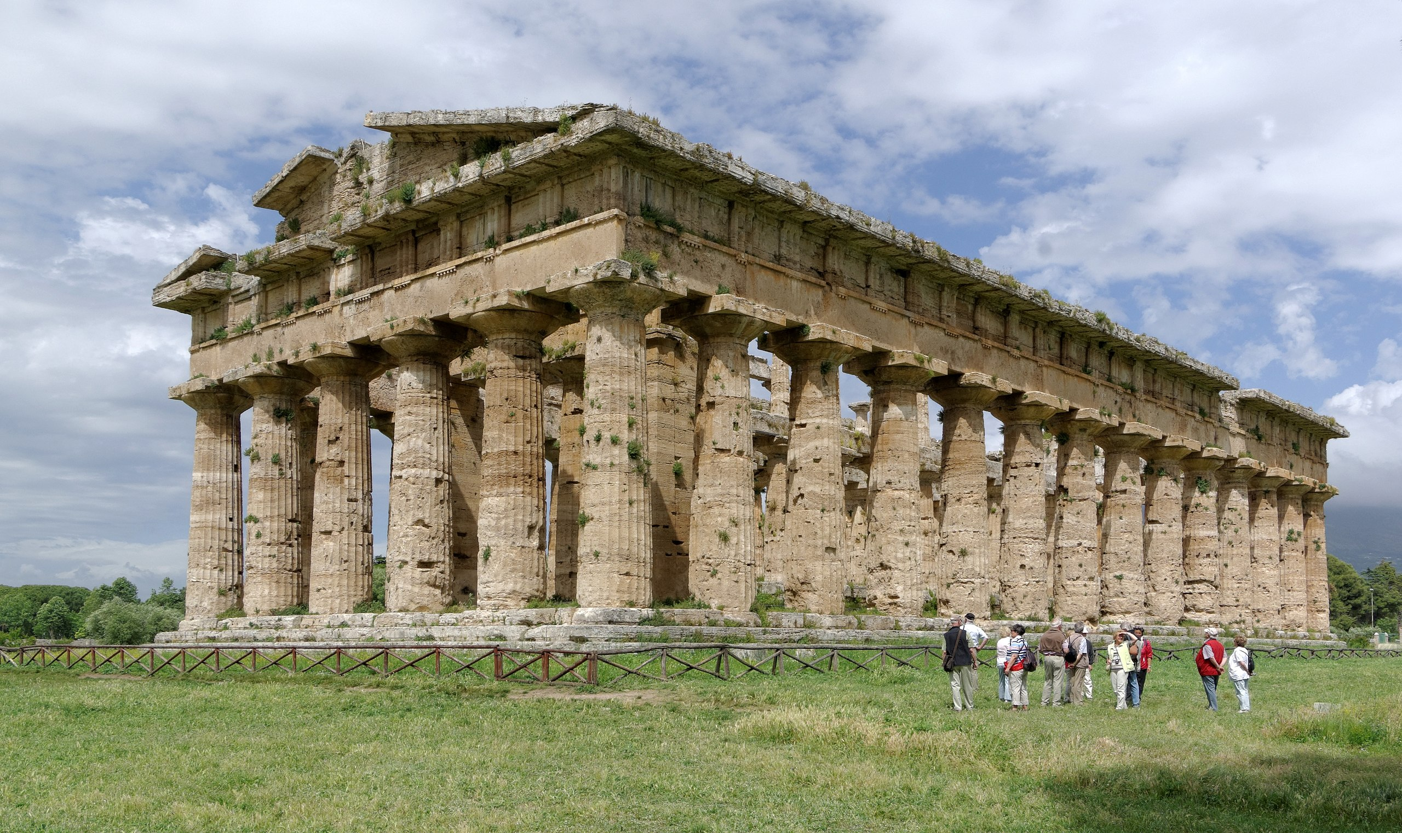
Day 8 (Wed 23 Oct) -- Naples to Paestum to Maratea. 0830. We check out of our Naples hotel to drive to Paestum, a fabulous site of Greek temples (part of the UNESCO World Heritage site that includes Cilento Park and coastline, the Diano Valley, and the philosophical ancient Greek city of Velia/Elia). Then we travel to the lovely village of Maratea, lunching along the way (not incl.). Free afternoon in this "the Pearl of the Tyrrhenian, with its membership in the I Borghi più belli d'Italia ("The most beautiful villages of Italy") association. Dinner on your own and overnight in Maratea (Hotel Borgo la Tana)

Day 9: (Thurs 24 Oct) -- Metapontum and other cities of Magna Graecia to Matera. 0830. We then take a lovely drive through the mountains to the south coast, pausing (if open) at the WWF sea turtle rescue at Policoro Herakleia, appreciating as well Basento, Cavone, and Agri Valleys. We discuss Heracleia and Sybaris and the dynamics of Magna Graecia (Greater Greece), stopping at the ancient Greek city of Metaponto (Metapontum). Then on to Matera. Dinner at Trattoria Caveoso (incl.) and overnight in Matera (Caveoso Hotel)

Day 10 (Fri 25 Oct) -- Matera. 0830. We take a walking tour of Matera (UNESCO World Heritage), starting with an overview of Sassi from Piazza Duomo, then short walk to Casa Naha for video of Sassi history and future. Then spend the day vising caves and cave dwellings, from the Neolithic to the twentieth century. Dinner on your own and overnight in Matera (Caveoso Hotel)

Day 11 (Sat 26 Oct): -- Lecce. 0830. Morning drive down the heel of Italy (Puglia), arriving in Lecce, where we will lunch (incl.) and take a walking tour of this spectacular Baroque town. Then free afternoon and evening. Dinner on your own and overnight in Lecce (Palazzo Rollo)

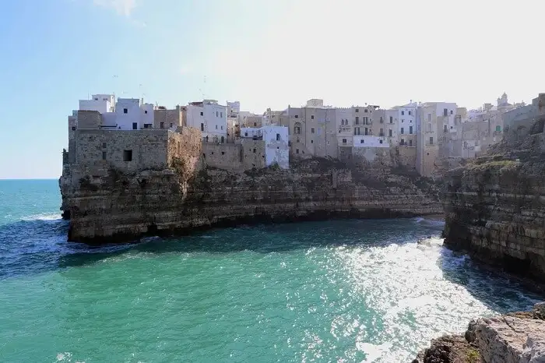
Day 12: (Sun 27 Oct) -- Ostuni, Alberobello, Castellana Grotte, Bari. 0830. We drive north, pausing in Ostuni, a maze of alleyways, staircases, arches, stacked houses, dead ends, pretty little gardens, glimpses of the Adriatic sea, and green doors. We’ll lunch there or in Alberobello (UNESCO World Heritage) and its trulli houses, Then we pass through the beautiful Valle d’Itria, to Castellana Grotte, before finishing up in Bari. Dinner on your own and overnight in Bari (Hotel Boston)

Day 13 (Mon, 28 Oct) -- Castel Monte, Bari: 0830. We go to Castel Monte (UNESCO World Heritage), of Frederick II, on the edge of Alta Murgia National Park. We return to Bari for lunch (not incl.), followed by an afternoon walkabout of Bari Vecchia (old town), with its lively atmosphere, Swabian Castle, Cathedral of Saint Sabinus, Teatro Petruzzelli, and Lungomare Nazario Sauro. Farewell dinner (incl.) and overnight in Bari (Hotel Boston)

Day 14 (Tues 29 Oct) -- flight home. We take you to Bari airport for your departure (incl).

DATES: 16 – 29 October 2024.
COST: € 4775 (euros) per person in double occupancy.

Tour Cost Includes:

- Bed and Breakfast accommodation on double or twin-sharing basis.
- breakfasts every morning and other meals as indicated in the itinerary as “incl”.
- Entrance fees for all activities mentioned in this itinerary, and only these.
- An English-speaking guide to be with you during all activities mentioned in this itinerary
- All presentations will be in English.
- Air-conditioned chauffeur-driven taxi or van where indicated by the word “drive” throughout the tour.
- All applicable government taxes, service charges, and paperwork.

Tour Cost Does not Include:

- Airfare.
- Passport applications and fees. Passports are required for entrance into Italy.
- Travel or health insurance. We recommend both.
- Single accommodation supplement charges (equaling 30% of the full tour cost)
- Any activities described as “options” or “optional” or “on your own”
- Meals or beverages not specified as “incl”.
- opera tickets
- Expenses of a personal nature.

Douglas Kenning / Lucia Davies / Stephen Davies
Sicily Tour
+393348828397
www.Sicily-Tour.com
sicilytour31@gmail.com

When we aren’t choosing the restaurant, we will have recommendations of our favorites.
literally “middle of the day”, i.e. “noon”, i.e. the part of Italy where the sun is hottest. The term includes Naples and Sicily.

