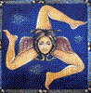
SICILY TOUR

Highlights of Sicily
Winter-Spring Tour Itinerary

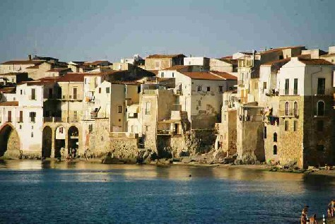
The best way to see Sicily is on a circular route, with Catania as the place to arrive and Siracusa the place to start. The east of the island is where it all began: prehistoric Sicily, the coast where the Greeks arrived, and Syracuse, where the first and greatest golden age of Sicily flowered. Then we follow a circular tour of the greatest sights of the island, returning to the east a restful epilogue at Taormina, before you leave for home from Catania. This is how you might understand Sicily as you enjoy her, in a relaxed and comprehensible chronological order.

Day 1 - Arrive in Catania. We meet you at the airport and take you to a charming hotel in the ancient city center of Siracusa, Ortigia. When everyone has arrived, we’ll have a welcome meeting. As you will be jet-lagged, the first day will be reserved for settling in and getting oriented. That includes an afternoon walk around the incredible island-peninsula of Ortigia, its palaces, narrow lanes, unique cathedral built within a Greek temple, Jewish Quarter, Arethusa fountain, and perhaps an optional puppet show. Welcome dinner at a favorite Siracusa restaurant (incl.) and overnight at Siracusa. (Hotel Livingston or equivalent)

Day 2 – Today is our grand tour of Siracusa, for two centuries the greatest of ancient Greek cities, beginning with one of the world’s two finest Greek Theatres, the Ear of Dionysius, and the Roman Amphitheatre. Free afternoon and overnight at Siracusa. (Hotel Livingston or equivalent)

Day 3 -- We drive to Noto, a Unesco world heritage site of honey-gold baroque. Then we drive out into the country for a lunch at a dairy farm where the Puglisi family treat us to produce of the farm (incl.). Then onto the charming town of Modica where chocolate is made in the traditional Aztec way brought to us by the Spaniards. Onto Ragusa Ibla and overnight in a charming hotel in town. (San Giorgio Palace hotel)

Day 4 - We start the morning with a short tour of Ragusa Ibla before going onto Caltagirone, the ceramics capital of Sicily. After lunch on your own we drive onto Piazza Armerina and a charming country hotel with views over to the city. Dinner (incl.) and overnight. (Torre di Renda or equivalent)

Day 5 - Visit of the amazing Roman villa at Piazza Armerina with the greatest mosaic floors of the ancient world. Then we travel further out across rolling countryside to the remote vineyards of Feudo Principi di Butera for a tasting and elegant light lunch (incl.). Finally, we take an afternoon drive on country roads to Agrigento. We arrive in Agrigento, walking a row of temples the equal to those in Greece itself. Dinner, on your own, and overnight in Agrigento in a hotel overlooking the temples. (Hotel Colleverde or equivalent).

Day 6 - We travel west along the less visited south coast to the ruins of the Greek city of Selinunte, the third great city of the Greek west, on its evocative windswept coastal site. We proceed through Marsala to the salt flats and romantic windmills of far western Sicily. Pizza dinner (incl.) and overnight in the old quarter of Marsala or in a restored nobleman’s estate in the countryside. (Hotel Carmine or equivalent).

Day 7 – We continue to Erice and tour the ancient mountaintop town founded by Aphrodite, ruled by Hercules, where a cult of sex once flourished. We sample the pastries at Maria Grammatico’s shop, made famous by Mary Simeti’s book Bitter Almonds. Turning north, we visit the incomparably beautiful temple at Segesta, a town Virgil tells us was founded by Aeneas. Finally, we visit the Norman cathedral of Monreale, one of the greatest buildings in the world. Dinner at one of the best restaurants for traditional Sicilian cuisine (Altri Tempi, incl.) and overnight in Palermo. (Hotel Piazza Borsa or equivalent)

Day 8 – A morning walking tour of the incredible sites of old Palermo, including matchless gems like the Palatine Chapel and La Martorana. In the afternoon, you are free to pursue your own interests in Palermo (we'll have recommendations). Dinner on your own and overnight in Palermo. (Hotel Piazza Borsa or equivalent)
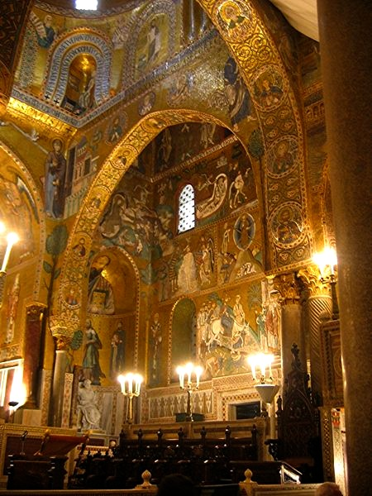
Day 9 – In the morning, we drive along the coast to the charming seacoast town of Cefalù, Then we continue into the Madonie mountains to our hotel, Relais Sant’Anastasia, in an ancient abbey where they have been making wines for a thousand years. Organic wine tasting with dinner (incl.). Overnight at Relais Sant’Anastasia. (Alternatively, we could remain in Cefalù for dinner at our favorite seafood restaurant overlooking the sea and overnight in old town Cefalù (La Plumeria Hotel or equivalent)), or drive further along the coast for dinner and stay at another mountain resort (Antica Filanda).

Day 10 – We drive to Taormina to check into your lovely hotel in Taormina with views over the sea. Walking tour of Taormina, focusing on the Roman theatre with its famous view of the coastline and Etna. We finish your tour with our “Arrivederci“ lunch at a favourite local restaurant (incl.), and free time for Taormina. (Hotel Villa Fiorita or equivalent).

Day 11 – We will take you to Catania airport for your flight home. (incl.)

cost: € 3570 per person in double occupancy in 2023
€ 3995 per person in double occupancy in 2024.

Tour Cost Includes:

- Bed and Breakfast accommodation on twin sharing basis. All accommodation will be of a three-star or higher standard, specially selected by us for quality, ambience, and the friendliness of the staff. All hotels have websites for your inspection.
- Ten breakfasts and nine other meals as indicated in the itinerary as “incl.”.
- Two winery tastings of Sicily wines.
- Cheese farm visit and lunch.
- Entrance fees for all activities mentioned in this itinerary, except those designated as “optional”, and only these.
- An English-speaking Sicily Tour host / guide to be with you during all activities mentioned in this itinerary.
- All presentations will be in English or an interpreter will be present.
- Air-conditioned chauffeur-driven vehicle throughout the tour.
- All applicable government taxes, service charges, and paperwork.
- Ground transport from and to Catania airport, at the beginning and end of the tour, within announced arrival & departure windows.

Tour Cost Does not Include:

- Airfare to and from Catania Fontanarossa Airport.
- Passport applications and fees. Passports are required for entrance into Italy.
- Travel or health insurance. We recommend both.
- Single supplement charges equaling 30% of the full tour cost
- any activities described as “optional”
- Meals or beverages not specified as “incl.”.
- Expenses of a personal nature.

-------------------------------------------------------------------------------------------------------------
3 We list it in euros because that is how we have to cost it out. Exchange rates fluctuate daily. How much the tour fee translates into in your home currency you bank will determine at the time you make payment.

4 Arrival Window: our pickup will collect you between 11~1400 on Day 1. Departure Window: we will take you to the airport on Day 11, if your flight is before noon, promising to have you at the airport no later than 75 minutes before your flight). See our “Terms and Conditions” page for more details.

5 Single Supplement fee is unfair, we agree. But there is nothing to be done, since hotels charge single travellers on average 80~90% of the room price for a couple. Best to bring a partner or ask us to help.

optional additions to the basic Highlights Tour

1. Taormina extension option (unlimited days after our tour)

After we have said goodbye and Sicily Tour’s responsibility for you has concluded (except for transfer to the airport), some people like to linger a few days in Taormina. It is, after all, Sicily’s focus for high-end shopping and elegant eating, for concerts, festivals, and visits to attractions like Daphne Phelps’ house, and for excursions around eastern Sicily as far as the Aeolian Islands.

If this appeals to you, let us know. With advance notice, we can arrange for you to stay over at the hotel for as many days as you like, and then still take you to Catania airport for your flight.

Cost: € 395 per couple per day (includes only the hotel & the difference in cost of a taxi just for you over the discounted rate we get for the usual Day 11 group transfer to Catania airport).

Just let us know if you are interested when first you sign on with us.

2. Mount Etna, cable car and jeep drive.

Etna is the world’s most storied mountain, one of its most resonant and mythic places. It is also Europe’s most active volcano and Sicily’s beloved grandfather (or grandmother depending on his/her mood).

We depart Taormina, ascending two-thirds up the slopes of Etna to the Rifugio Sapienza area. At this point, there will be a cable-car and 4WD service ( incl.) up another 4000 feet to see up close the smoking vents in the company of an official Etna alpine guide. Later we proceed down the east slopes of Etna. Wine-tasting and outdoor light lunch (incl.) at a small boutique winery with views over the Mediterranean. We take you to your hotel in Taormina.

Please ask for a quote for this option. The cost of which is dependent on whether you have booked your own hotel or whether you wish to prolong your stay at your hotel.

Stephen Davies / Douglas Kenning / Lucia Davies
Sicily Tour
+393348828397
www.Sicily-Tour.com
sicilytour31@gmail.com

if performing on this day, not included.
if our tour is less than half full, we might substitute an al fresco lunch in a favourite Slow Food restaurant in Piazza Armerina.

